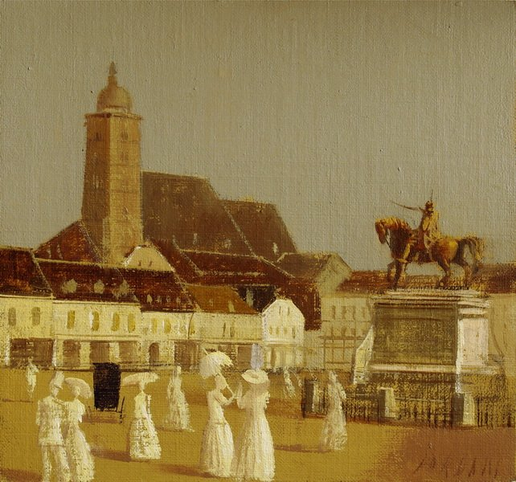 | 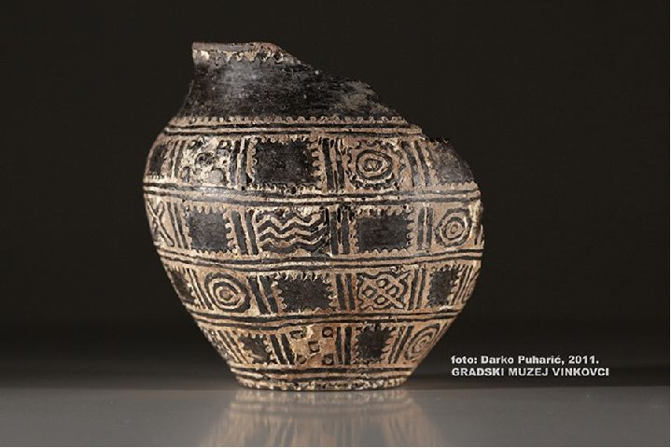
Croatian Painting - Vasilije Jordan | Croatian Photograph - Darko Puharic
French Painting - Le pont de l’Europe de Caillebotle | French Photograph - Yann Arthus Bertrant
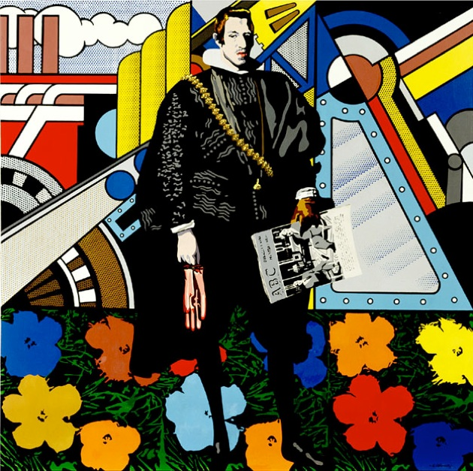 | 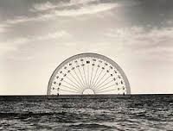
Spanish Painting - Equipo Crónica | Spanish Photograph - Chema Madoz
Swedish Painting - Sven Jonson | Swedish Photograph - Rivningen

