Project "Arts Count!"
Art and Mathematics
Task 1
Introduction
The search for mathematical explanations of nature and the universe has always occupied mathematicians, and also the artist who believed that this is the only way they can achieve ideal beauty, apropos perfectly harmonised art piece.
The old Egyptians discovered the "Golden section" (the Golden ratio), so called the Divine proportion, which is still considered as the perfect proportion in nature. We can get a Golden section by dividing a line into 13 pieces, a then we divide them in a proportion 8:5, which is total 1.618. That`s how we get a proportion in which the smaller size relates to the bigger one, as well as the bigger one relates to the entirety or a : b = b: (a+b).
We will show the connection between Art and Math on these art pieces: Zobnica, Diocletian`s palac and Ivan Piceljs `s painting: From the map Ulm`s variations.
Usable item: Zobnica
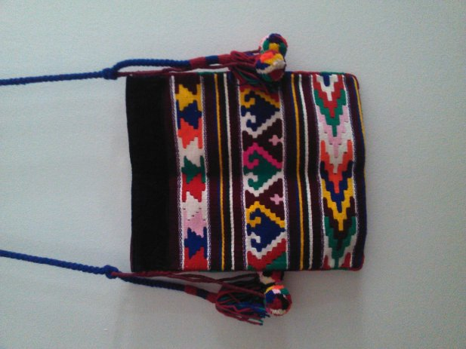
1. Write a short history of the item and learn where it was used.
2. Which geometric shapes were used for making zobnica?
3. If the length of zobnica is ? cm, the wight is ? cm, calculate a total amount of material needed to make zobnica.
Links were you can find answers to the questions:

https://hr.wikipedia.org/wiki/Pravokutnik
https://www.mathsisfun.com/geometry/
Building: the floor plan of Diocletian`s palace
1. Write a short history of Diocletian`s palace.
2. Learn of which geometrical shapes floor plan is comprised , and which shapes are repeated.
3. Find the use of Golden section inside the palace.
4. Find the connection between the Diocletian`s palace and weaving workshops (??)

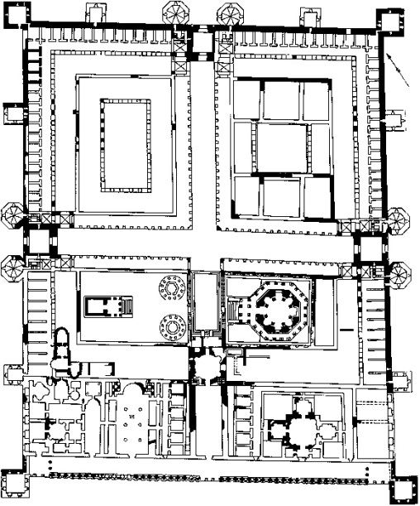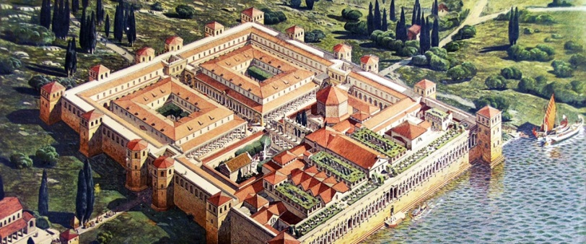
Links were you can find answers to the questions:

http://splitculture.hr/dozivljaj/povijest/dioklecijanova-palaca
http://www.visitsplit.com/en/448/diocletian-palace

Ivan Piceljs `s painting: From the map Ulm`s variations
1. Write a short biography about Ivan Picelj.
2. Comment the painting from geometrical point of view:
-Which geometrical shapes are present in the painting?
-Find parallel lines in the painting.
-Learn and find the Golden section inside the painting.
Links were you can find answers to the questions:

http://www.galerijadivila.hr/hr/autori/ivan-picelj.html
https://en.wikipedia.org/wiki/Ivan_Picelj
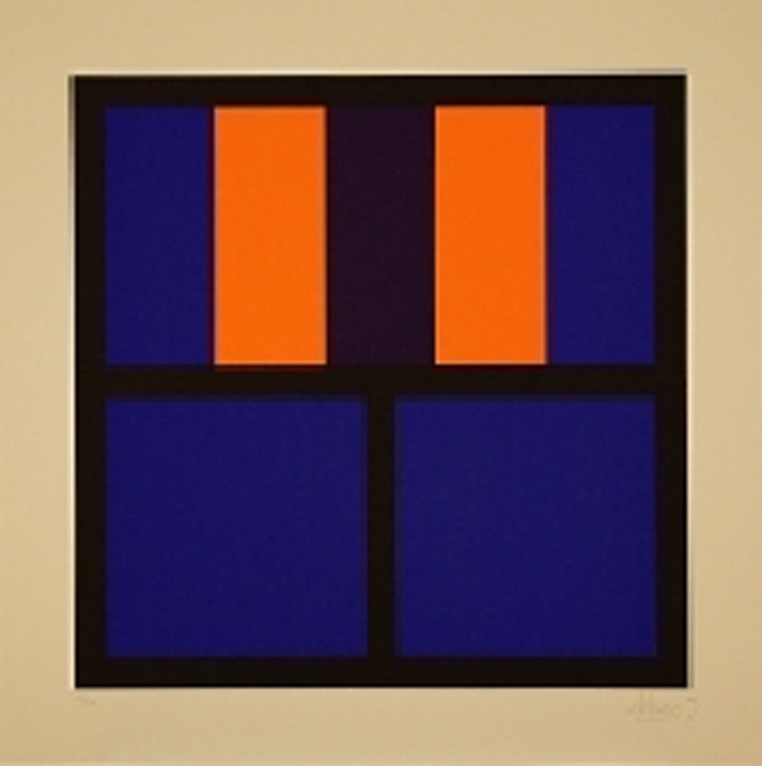

The technic of cooperative learning
For making this task done, we have to use the technic of a puzzle. First, we will be divided into 4 groups. Each group has 4 members and each group will be working on a part of the assignment.
The first group is supposed to learn and explore given art pieces and write a text about it with mathematical elements included. Afterwards, they will hand over their text to the second group who will be doing a script for the film. The third group will record a video based on the script while the fourth group will computerise it.
Although each student will be working just on one part of the assignment, every part of the task is connected. At the end, each student will gain a knowledge about the parts they didn`t work on.

